Older Beretta and MecGar magazines were die stamped before being folded and welded leaving very crisp edges over the entire body. The new generation of Beretta produced 80X magazines have moved away from the expensive die stamping process and now use lasers to cut out the flats that will eventually become magazine bodies. While very precise, the end of these cuts often leave a small, almost unnoticeable ball of slag. This small imperfection is usually not an issue when using flat bottom plastic base plates as there is a significant amount of slop in the tolerance of these meant to make them very easy to get on and off for maintenance.
Our AGW +2 base plates for the Beretta 80 series double stack pistols are made to the highest standard of quality and designed to fit tightly to the magazine body in order to ensure the greatest amount of reliability possible. As such, the small ball of slag found on the base plate lips can make our plates extremely difficult, if not impossible to install. Fortunately, removing this flaw is fast and easy.
As you can see in the below photo, there is a bit of metal at the beginning of the lip that increases the thickeness of the metal by nearly half again the original thickness. This is more than enough to cause fitment issues with our plates.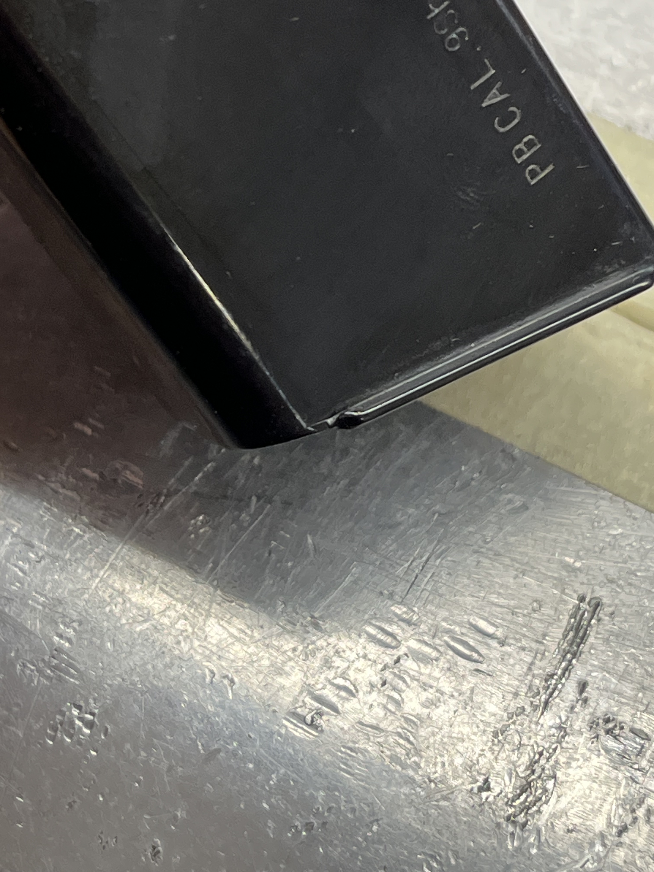

If you find your base plates hard to install, simply remove this edge using a small needle file, or even a metal nail file. Scrub the offending area until the leading edge is the same thickness as the rest of the lip test fitting the plate as you go until it slides on with little to no effort and once complete, simply install the plates normally.
